Project Team Development Environment Setup (DES)
for the DotNetNuke Gallery Module 4.3.0
The Gallery project team has been experimenting with several alternative approaches to building and packaging DNN modules. In the source package you will find two sets of solution and project files:
- DotNetNuke.Modules.Gallery.sln and DotNetNuke.Modules.Gallery.vbproj – these VS 2008 solution and project files provide for the customary development of the module inside the DesktopModules\Gallery folder. A NANT.build file is provided in the Buildfiles folder for those who which to use a NANT script with this project file for package creation. NOTE: The team stopped using the NANT script several months prior to the completion of this version. Therefore, the NANT script may need some manual adjustments to successfully create packages. Please use at your own risk.
- DotNetNuke.Modules.Gallery_DES.sln and DotNetNuke.Modules.Gallery_DES.vbproj – these provide an alternative approach which includes development outside of a DesktopModules subfolder and use a custom MS Build targets file and several tasks from the MS Build Community Tasks project to copy various .ascx user control files, localization files, and other resource content back into the DesktopModules\Gallery folder following each build AND when the build configuration is set to Release, create both install and source package zips. The following instructions were written for project team members who have access to the source code repository via the Fortress client. As non-team members will not have access to this repository referenced in steps 4 and 5 below, you will need to un-zip the source package (and its embedded Resources.zip archive) into the _modules\DNN\DotNetNuke.Modules.Gallery folder which you will be creating.
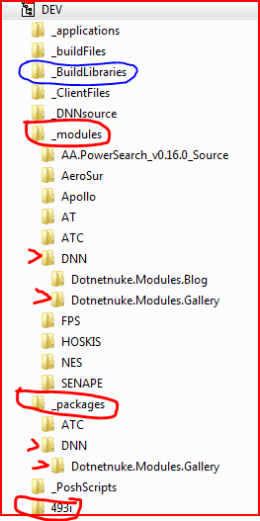
Development Environment Setup (DES) Instructions
- Create the following directory structure:
(Root)
|-> 493i
|-> _buildlibraries
|-> _modules
|-> DNN
|-> Dotnetnuke.Modules.Gallery
|-> _packages
|-> DNN
|-> Dotnetnuke.Modules.Gallery

In this structure, (Root) represents the root folder for the development environment. Bill Severance’s root is C:/DNN Development while Néstor Sánchez’s is D:/Dev. It doesn’t matter where you place the root, the important thing is that the appropriate permissions are set, specially for the DNN website.

- Extract a new DNN 4.9.3 install package in the 493i subfolder and create a new website (Windows Server, Vista, Windows 7) or a new virtual directory in Windows XP pointing to the 493i folder. Notice that the Dotnetnuke.Modules.Gallery vbproj file currently references “493i” (like in the illustration to the right) as the name of the website and as a nod to the current DNN minimum version. It is possible to use any name in both the folder and in IIS as long as the same name is used in the reference inside the project file. For example “localhost/dotnetnuke” for Windows XP and “MyDNNWebsite” for all other platforms.

- Download the latest installer file for Microsoft Community Tasks, MSBuild.Community.Tasks.msi from http://msbuildtasks.tigris.org/. Install MCT using the default options. Optionally, you may wish to copy the tasks target file MSBuild.Community.Tasks.Targets from its default location C:\Program Files\MSBuild\MSBuildCommunityTasks to the newly created _buildlibraries folder. This will be helpful should you wish to later customize the MCT targets file but have the default MCT targets file available for other projects. The Gallery project file will locate the MCT targets file in either directory.
- Open the Gallery repository in the Fortress client and reset its working directory so that the repository folder Source/AspNet20/DesktopModules/Gallery points to the newly created folder of your local development environment: (Root)/_modules/DNN/Dotnetnuke.Modules.Gallery
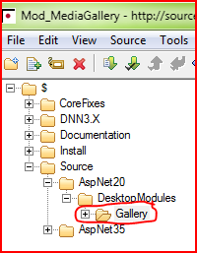
- Perform a “Get Latest” command in Fortress client to download the latest source files including the new project file.
- Using VS 2008 SP1 or VS 2005 SP1 open the gallery project solution file (Dotnetnuke.Modules.Gallery_DES.sln for VS 2008) found in the directory (Root)\_modules\DNN\Dotnetnuke.Modules.Gallery.
- You may find that the solution is not able to load the project file Dotnetnuke.Modules.Gallery.vbproj and receive an error message relating to source control, “An error occurred registering this project with source control . . . “. If you do not wish to use source control from within Visual Studio, simply edit the project file (while the project is unloaded from VS 2008) to remove the four xml elements found near the top of the file: “<SccProjectName”, “<SccLocalPath”, “<SccAuxPath”, and “<SccProvider”. Save the modified project file then attempt to reload the project. If you do wish to have the project files under source control while in Visual Studio, this error may be due to VS still being configured to use either the SourceGear Vault Client or SourceGear Fortress Classic Client rather than the now required SourceGear Fortress Visual Studio Enhanced Client. This may be changed in VS by opening the Tools→Options→Source Control menu item and changing the current source control plug-in to “SourceGear Fortress Visual Studio Enhanced Client”. 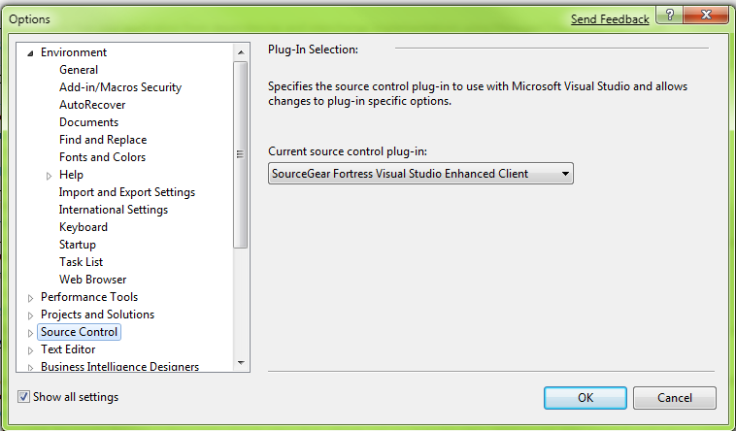
- Following the change of plug-ins, you will need to rebind the project file to source control using the Visual Studio menu item File→Fortress Source Control → Change Fortress Bindings.
- Remove the ReadOnly property from the following files in the _modules\DNN\Dotnetnuke.Modules.Gallery folder: Dotnetnuke.Modules.Gallery.dnn, AssemblyInfo.vb, and Version.txt. Members from the testing team should never upload a new Version.txt file to Fortress. We are keeping track of revisions now, and builds made by testers are not considered revisions.
- Note that should when a change is made to either the project or custom targets files, (Dotnetnuke.Modules.Gallery.vbproj and/or BuildFiles\Dotnetnuke.Modules.GalleryBuild.targets), you must unload the gallery project then reload it for the changes to take effect.
- Attempt to build the Gallery project. The newly created packages resulting from the build will be found in the _packages folder. As part of the build process, all necessary files will be copied automatically from their development location in the _modules\DNN\Dotnetnuke.Modules.Gallery folder to the appropriate \bin and \DesktopModules\Gallery folder of the 493i DotNetNuke website so that you will be able to then be able to start debugging, etc. following the build.
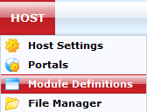
After initializing the new DNN 4.9.3 site and performing any desired configuration, Gallery does not exist yet as a module. To add it: Select Host->Module Definitions and then select “Import Module Definition” from the Module Definitions module.
- The Gallery manifest should be listed in the Manifest dropdown. After clicking Import Manifest, Gallery will be ready to be used. 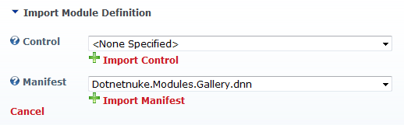
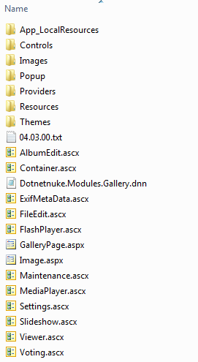
- The structure of your module should resemble the graphic on the right. The dnn manifest file remains and is not renamed dnn.config, like in a normal installation.
- Note that the new environment setup and particularly the structure of the Dotnetnuke.Modules.GalleryBuild.targets file is still being refined and most likely will change as time goes on. The next major enhancement to the process will be to set up the tasks to upload nightly builds to the project’s CodePlex site. It is also hoped that a standard development environment and MS Build process will be created for all DNN module project teams to use.

